

The Geological Society of London:
East Midlands Regional Group Talk
The “boring” truth about BGS
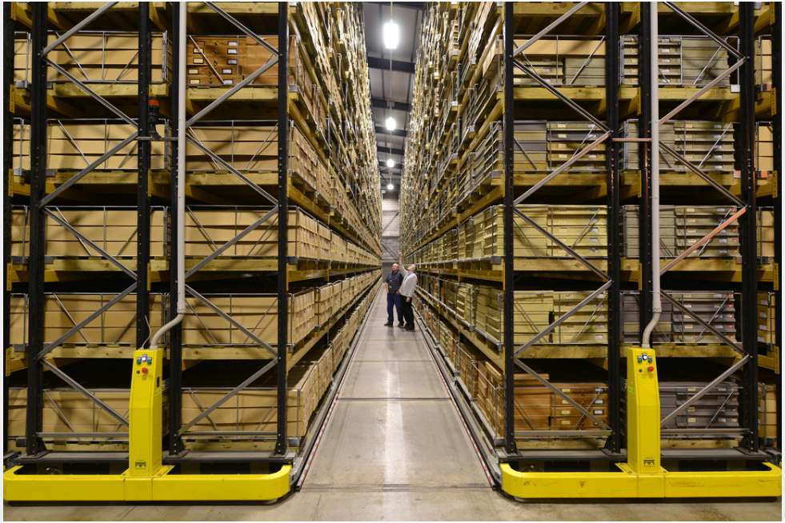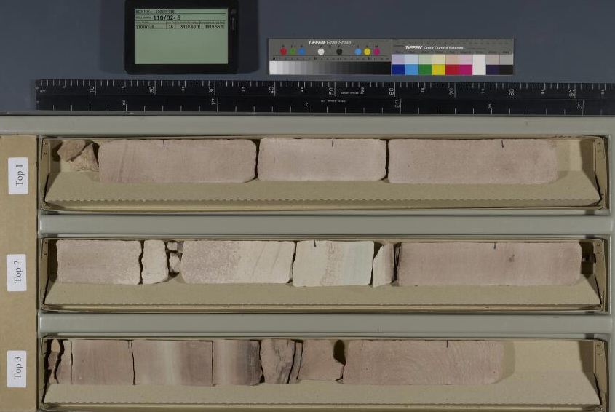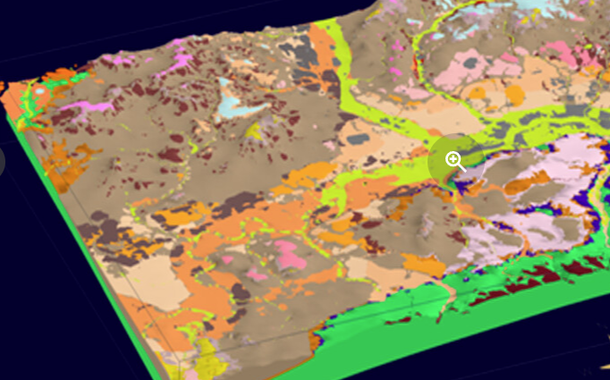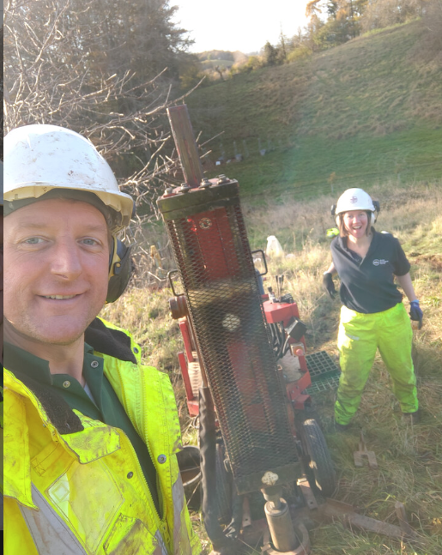

Steve Thorpe (BGS)

Steve Thorpe will explore the topic of boreholes at the British Geological Survey and cover their use in mapping and 3D geological modelling. Steve has a 20 year career at BGS and has worked with boreholes all this time including being manager and lead driller on BGS’ own drilling rig facility. Steve will also discuss the technological changes in the way borehole information is now recorded and will present on a few of his achievements in trying to encourage and share borehole data with the construction and civil engineering industry, in order to help reduce costs, time savings and reduce health and safety risk in the process of collecting ground information.

19:00 Tuesday 25th November 2025
TEAMS virtual meeting only

