Geological Society Discussion Group – Christmas Dinner

Friday the 4th December 2026

The Discussion Group – the Dining Club of the Geological Society – is delighted to invite members, guests and newcomers to the 2026 Christmas Dinner. We shall return to the Athenaeum Club for the first time since our Bicentenary dinner for another evening of fun and fine conversation.

This year we are particularly encouraging new attendees from across the Society’s Special Interest Groups and beyond to join us to make an event to remember. So join us around the Christmas Lepidodendron to meet other Fellows and share stories from across the geological sciences.

The dinner will be held 6pm for 6:30pm on Friday the 4th of December at the Athenaeum Club on Pall Mall. The dinner will include a three-course dinner, and tea, coffee and port to finish. The cost of the dinner is £70 for Dining Club members and their guests, £80 for other Society Fellows and their guests

We wish to bring as many Fellows together as possible, so do please invite those who you feel may be interested in attending this event.

A sign-up form is provided overleaf. In order to get an accurate indication of numbers for the venue I would be grateful if you could respond to this invitation as early as possible before the deadline of the 20th November 2026.

Yours Sincerely,
Dr Andrew Dobrzański FGS
Chair, Geological Society Discussion Group

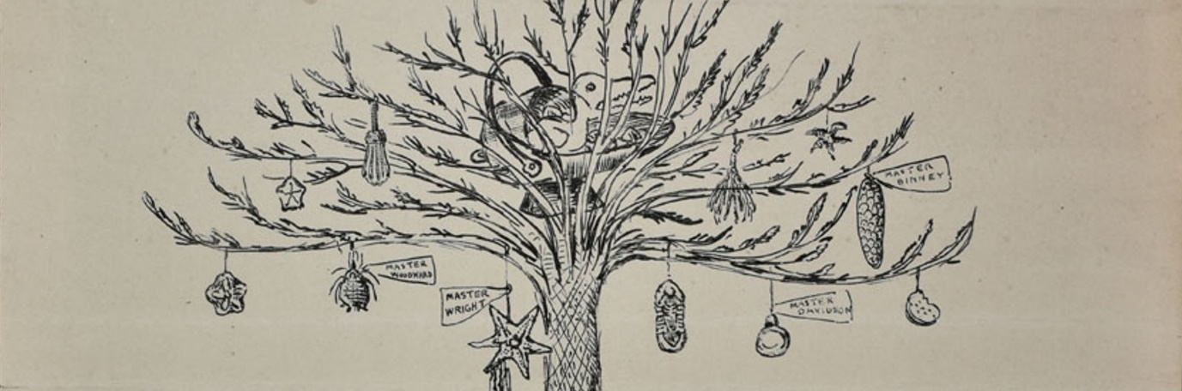
Geological Society Discussion Group – Christmas Dinner
Friday the 4th December 2026
St Barbara’s Day, the Patron Saint of Geologists

Athenaeum Club, Pall Mall
6:00pm for 6:30pm

Dress Code: Jacket and Tie or Equivalent

Registration and Payment Details

Tickets are £70 for Club members and their guests, £80 for other Fellows of the Society and their guests. Payment details are at the end of this form.

Menu:
Suitable alternatives will be provided for those with dietary requirements.

Starter | Gin And Juniper Marinated Salmon, Dill Sour Cream, Rye Bread and Lemon
Main | Slow Cooked Lamb Shank, Black Garlic Mashed Potatoes, Root Vegetables, Rosemary Sauce
Dessert | Brioche Orange Marmalade Bread and Butter Pudding, Custard
To Finish | Tea, Coffee, Port

To register for our Christmas dinner please complete the form below and return by email to Dr John Bennett, Club Secretary at: jnbgeo@protonmail.com

Personal Details:
Names in the Party: | Email: | Any Dietary Requirements:

I request the following  number of tickets: | £70 Club Members and Guests | £80 other Fellows and Guests
I request the following  number of tickets: | __________ | __________

Payment Details:
Please pay to: Geological Society of London
Account Number: 02455676
Sort Code: 18-00-02
With Reference: GSDG-[Surname]2026

