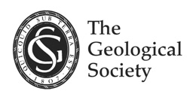
The Geological Society of London:
East Anglian Regional Group
serving science, profession & society
serving science, profession & society
Conference and Field Trip
Industrial Legacy of Town Gas Works:
Managing Contaminated Land
This event brings together a series of concise, expert-led lectures exploring the history of town gas manufacture in the United Kingdom and its relevance to contaminated land management. The sessions will cover key themes including; historical context, common contaminants, risk assessment, and remediation strategies, delivered by five leading industry professionals.
Designed to provide an insightful introduction for early-career professionals in the geotechnical and geo-environmental sectors, the event also serves as a valuable refresher for experienced practitioners and regulators.
Following a light lunch and refreshments, attendees will enjoy an interactive afternoon hosted by the knowledgeable trustees of the Fakenham Town Gas Museum. This hands-on session will include guided visits to key areas of the former town gas works (itself a scheduled monument), offering a deeper understanding of the processes involved. Our speakers will also be available to answer questions and provide additional commentary throughout the visit.
This unique combination of expert insight and practical exploration promises to deliver a highly engaging and informative learning experience for all participants.
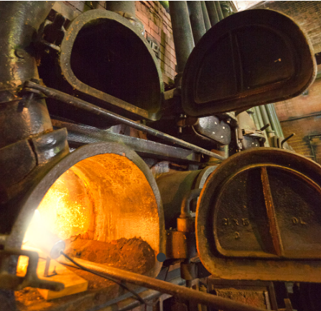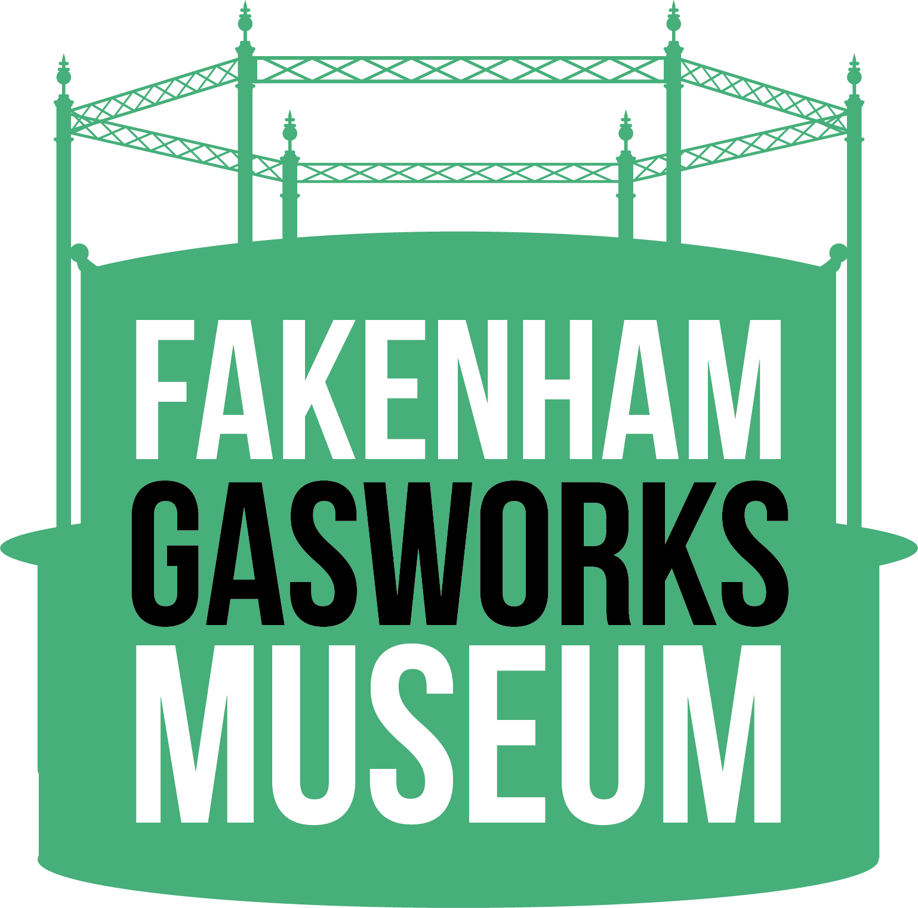
Tuesday 21 April 2026
0930 arrival. Talks begin at 1000
Museum tours from 1400
Adrian Flux Bar, Fakenham Racecourse, Fakenham, NR21 7NY
then
Fakenham Town Gas Works Museum
Hempton Road, Fakenham, Norfolk, NR21 7LA
Disabled parking on site by prior arrangement
Parking at James Beck Auctions car park, NR21 9TD W3W: sharper.gems.grunt
Event tickets are £5 and can be booked here.
After Eventbrite’s service fee and tax deductions, the net proceeds from ticket sales will be donated to
Fakenham Town Gas Works Museum Trust (registered charity No. 1996354).
Ticket sales end 10 April 2026 (unless sold out) so please book early to avoid disappointment.
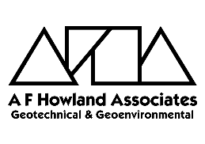
This event is kindly supported by our colleagues at the East Land Quality Forum, and sponsors A F Howland Associates and Normec DETS.

