WRG Summer Field Trip: The Avon Gorge
Richard Arthur
2pm Sunday 25th September 2016
Circular Road on the Downs, Avon Gorge

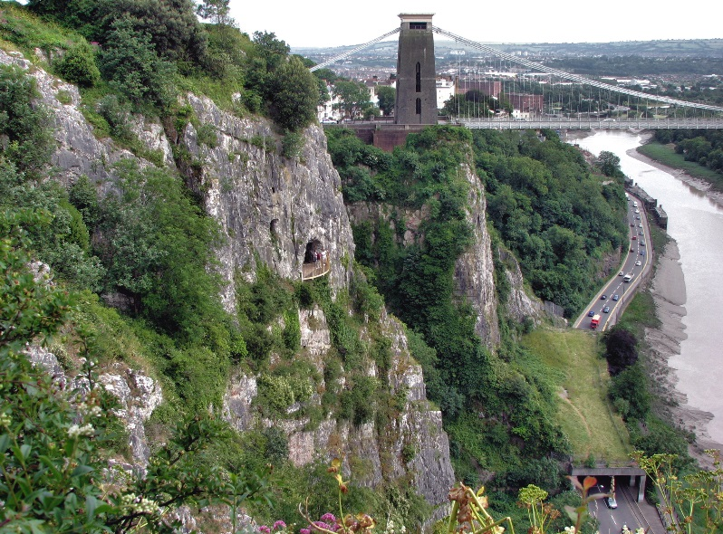
The Avon Gorge is an exceptionally good place in Britain to see and learn about geology. For a long time, it was unclear what caused the River Avon to cut through the limestone ridge rather than run south west through Ashton Vale towards Weston-Super-Mare. We now know that the Avon was formed during the last ice age when the original river channel to the south was blocked, forcing it to cut its way down through an anticline of carboniferous limestone and old red sandstone. The resulting gorge, spanned by the Clifton Suspension Bridge, is an iconic Bristol landmark.

There are easily accessible rock exposures that reveal a complete succession of local Carboniferous limestone, truncated by the Avon Fault. We will also see a variety of fossils including brachiopods, corals, and crinoids which have been particularly exposed by the historic mining along the Portway.
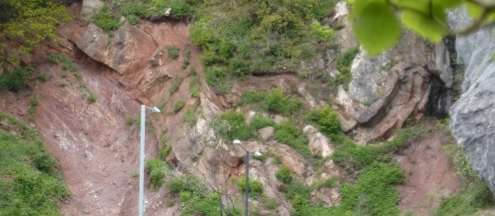
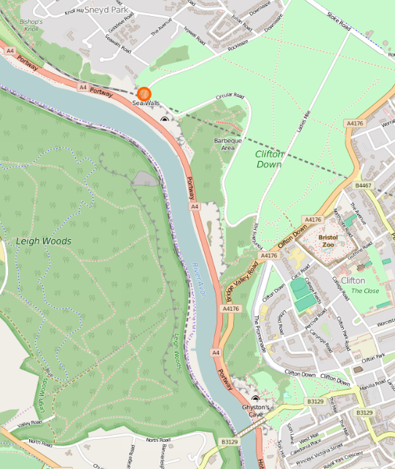
This year’s WRGS field trip will be led by Richard Arthur. We will be meeting on the Circular Road on the Downs at the Avon Gorge Viewpoint (Sneyd Park, Bristo, BS9 1PG, where the ice cream van parks). The fieldtrip will consist of a circular walk, probably taking 2.5hrs. We will be starting at the viewpoint, walking down to the Portway, along the Portway, up Bridge Valley Road and back to the original starting point. We will see lots of exposures including dolomitic conglomerates and fossilised crinoids along Bridge Valley Road (which will be shut to road traffic) and faulting amongst others. We recommend walking/safety boots as a minimum.
Clifton
Meeting here

After the field trip we will be travelling back into Clifton and will order food and/or pint at one of the local pubs. The cost of the trip is FREE. Please e-mail Louisa.McAra@atkinsglobal.com to reserve your place.

